主题：教育水平

题型：柱状图

The charts below show the levels of participation in education and science in developing and industrialize countries in 1980 and 1990.

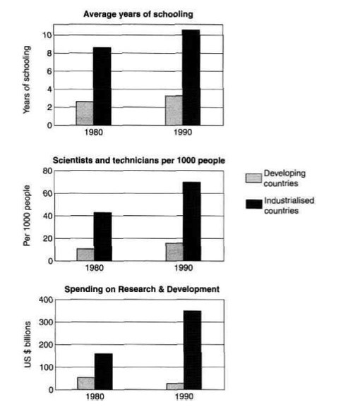

满分范文：

The three bar charts show average years of schooling, numbers of scientists and technicians, and research and development spending in developing and developed countries. Figures are given for 1980 and 1990.

It is clear from the charts that the figures for developed countries are much higher than those for developing nations. Also, the charts show an overall increase in participation in education and science from 1980 to 1990.

People in developing nations attended school for an average of around 3 years, with only a slight increase in years of schooling from 1980 to 1990. On the other hand, the figure for industrialize countries rose from nearly 9 years of schooling in 1980 to nearly 11 years in 1990.

From 1980 to 1990, the number of scientists and technicians in industrialize countries almost doubled to about 70 per 1000 people. Spending on research and development also saw rapid growth in these countries, reaching $350 billion in 1990. By contrast, the number of science workers in developing countries remained below 20 per 1000 people, and research spending fell from about $50 billion to only $25 billion.